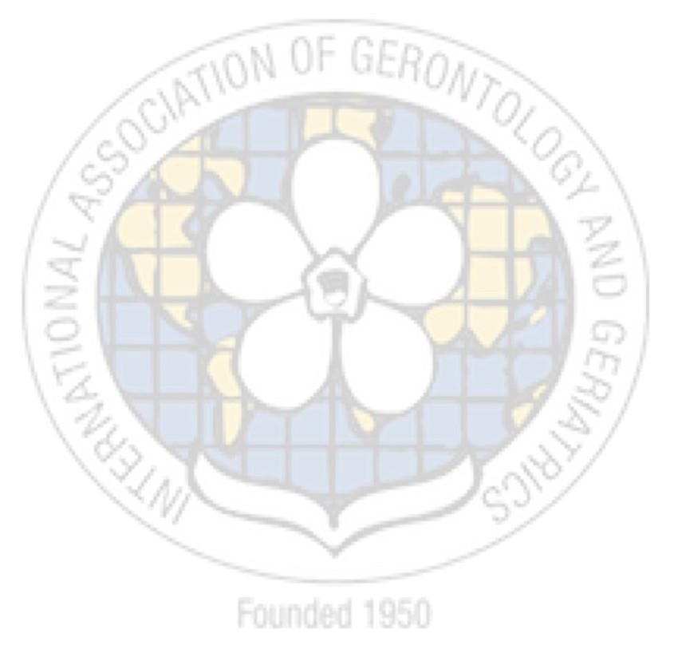www.iagg.info

NEWSLETTER

NEW YORK, OCTOBER 2017
VOL. 21 / NO. 02

INDEX
EDITORIAL 3
USA SECRETARIAT 5
NEW EXECUTIVE COMMITTEE MEMBERS 6
IAGG 21st CONGRESS 8 IAGG REGIONAL NEWS 12 IAGG PROGRAMS 17
IAGG & UNITED NATIONS 19
EVENTS 20
IAGG ADMINISTRATION 22

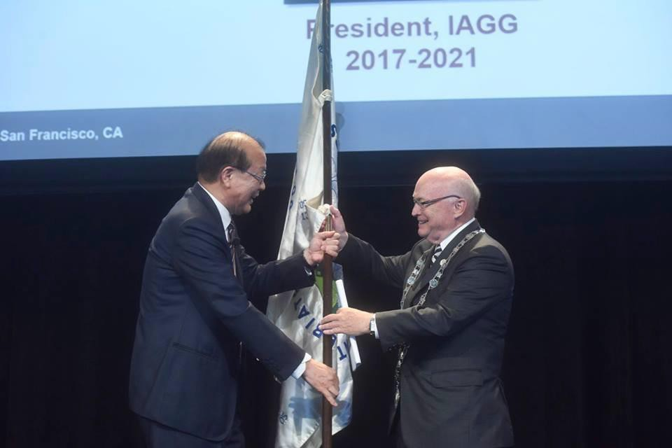

Transfer of Presidency: During the 21st IAGG World Congress held in San Francisco, CA this past July. The picture captures the transition in Presidency from Dr. Cha (Korea, 2013-2017) to current President Dr. John Rowe (United States, 2017-2021).

John W. Rowe, MD, IAGG President
As the International Association for Gerontology & Geriatrics begins its 17th term, I am sincerely delighted, and honored, to serve as IAGG’s President for the next four years. On the heels of a successful conference, hosted by the Gerontological Society of America (GSA), I would like to express my deep appreciation for James Appleby, Executive Director and Chief Executive Officer of GSA, and his planning committee members. The 21st IAGG World Congress of Gerontology and Geriatrics (IAGG 2017), held in San Francisco, with its top-notch technical programs and exciting social events, reflects the tireless and detailed efforts of GSA’s entire staff.

This year’s conference drew in more than 6,000 participants from 79 countries outside the United States, and featured 693 sessions during the five-day event. Most importantly, IAGG 2017 reminded us that there is nothing more powerful than when our community comes together in an open dialogue to reflect on our progress and further our initiatives to advance healthy aging. In keeping with this mission, it is incumbent upon us to engage in ongoing global communication, research and education to ensure advances are made and milestones are met within the fields of gerontology and geriatrics.

As we embark on a new term, I would like to thank the outgoing administration and executive officers for their invaluable contribution to IAGG's success during the past four years, while extending a warm welcome to the members of IAGG's new executive committee and its growing membership. It is my privilege to serve with you as we accept the challenge of taking the organization to new heights.

Thank you all for your many contributions to the field of aging, and for advancing the positive influence of this very important organization!

John W. Rowe, MD President
International Association of Gerontology and Geriatrics

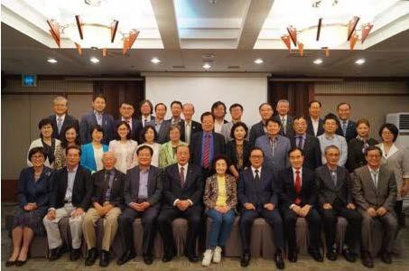
Announcing the World Ageing Center Project: At the closing ceremony of IAGG Korea Secretariat, on September 21, 2017 at the Press Center in downtown Seoul, Professor Jong-Lull Yoon, President of Korean Association of Gerontology and Geriatrics, announced the official commencement of the World Ageing Center Project and appointed six researchers.

Heung Cha, MD, PhD, Past IAGG President
I would like to extend my heart-felt congratulations on the great success of the 21st IAGG World Congress, which turned out to be the biggest event in IAGG's 67-year-long history, attracting more than 6,000 participants and providing an excellent venue for international academic exchange.

The main theme of the 2017 San Francisco Congress, ‘Global Aging and Health: Bridging Science, Policy and Practice’, clearly showed how we should cope with the challenges of a global aging population, highlighted in the opening speeches by Jo Ann Jenkins, CEO of AARP, titled ‘Disrupt Aging’ and by Dr. Linda Fried titled ‘Benefiting from the Third Demogr aphic Dividend’. Both Jenkins and Fried stressed the need to tackle more actively and positively the challenges of a global aging population and provided important clues to academic research and strategic options in the years to come.

As Immediate-Past President, I am fully committed to the ongoing efforts of IAGG. I will be serving as one of the UN Representatives of IAGG, participating and discussing topics of global population aging during the UN Economic and Social Council meetings, with particular focus on the early conclusion of ‘UN Convention on Human Rights of Older Persons'.

Heung Bong Cha, PhD Past-President
International Association of Gerontology and Geriatrics

President:John W.Rowe, MD Dr. John W. Rowe is the Julius B. Richmond Professor of Health Policy and Aging at the Columbia University Mailman School of Public Health. Previously, from 2000 until late 2006, Dr. Rowe served as Chairman and CEO of Aetna, Inc., one of the nation's leading health care and related benefits organizations. Before his tenure at Aetna, from 1998 to 2000, Dr. Rowe served as President and Chief Executive Officer of Mount Sinai NYU Health, one of the nation's largest academic health care organizations. From 1988 to 1998, prior to the Mount Sinai-NYU
Health merger, Dr. Rowe was President of the Mount Sinai Hospital and the Mount Sinai School of Medicine in New York City. Before joining Mount Sinai, Dr. Rowe was a Professor of Medicine and the founding Director of the Division on Aging at the Harvard Medical School, as well as Chief of Gerontology at Boston's Beth Israel Hospital. He was Director of the MacArthur Foundation Research Network on Successful Aging and is co-author, with Robert Kahn, Ph.D., of Successful Aging (Pantheon, 1998).

Currently, Dr. Rowe leads the Aging Society Network. He was elected a Fellow of the American Academy of Arts and Sciences and a member of the National Academy of Medicine. He serves on the Board of Trustees of the Rockefeller Foundation, the Board of Fellows of Harvard Medical School, and recently stepped down as chairman of the board of overseers of Columbia University's Mailman School of Public Health. He was founding Chair of the Advisory Council of Stanford University's Center on Longevity, a founding Commissioner of the Medicare Payment Advisory Commission (Medpac) and Chair of the Board of Trustees of the University of Connecticut and the Marine Biological Laboratory.

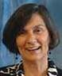
Secretary General: Toni Antonucci, PhD Dr. Toni C. Antonucci is an Elizabeth M. Douvan Collegiate Professor of Psychology, Program Director and Research Professor in the Life Course Development Program at the Institute for Social Research and Associate Vice President for Research, all at the University of Michigan. She was President of the Gerontological Society of America and the Society for the Study of Human Development and served as Editor of the Journal of Gerontology: Psychological Sciences. She is a member of the Executive Board of the International Society for the
Study of Behavioral Development and Secretary General-elect of the International Association of Gerontology and Geriatrics, and served as past Chair of the American Psychological Association's Committee on Aging and Board of Scientific Affairs. She is a fellow of the Gerontology Society of America, American Psychological Association, and the Association of Psychological Science.

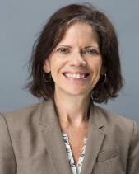
Treasurer: Jacqueline Angel, PhD Jacqueline Angel is a Professor of Public Affairs and Sociology and a Faculty Affiliate at the Population Research Center and LBJ School Center for Health and Social Policy at The University of Texas at Austin. Her research addresses the relationships linking family structures, inequality, and health, including a special focus on the impact of social policy on minority aging, the Hispanic population, and older Mexican Americans. In the City of Austin, she is a member of the President’s Council at Family Eldercare and a 2013 recipient of the Jackie Lelong
Visionary Leader Award. Dr. Angel currently sits on the City’s Commission on Seniors, a four-year appointment, is a Fellow of the Behavioral and Social Sciences section, and has served as Chair, Secretary, and Treasurer of the Section on Behavioral and Social Science of The Gerontological Society of America (GSA). She also serves as a Senior Fellow at the Sealy Center on Aging, UTMB School of Medicine and as an advisor to professional committees, non-governmental organizations and other agencies that provide basic services to older adults. Previously she served on the U.S. Public Health Service, National Institutes of Health NIA Behavior and Social Science of Aging Review Committee, which she also chaired for two years.

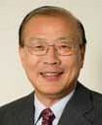
Immediate Past IAGG President: Heung Bong Cha, PhD Professor Cha graduated with a degree in sociology from Seoul National University and obtained his PhD at Choong-Ang University in Korea. He began his career in 1971 in the Government of the Republic of Korea as Junior Secretary to the President. he then became Director of the Social Welfare Department and the Health Insurance Department of the Ministry of Health and Welfare of the Republic of Korea. He served as the ROK Minister of Health and Welfare (1999-2000) and is currently President of the
Korea National Council on Social Welfare (2011- present). From 1983 to 2008, Professor Cha joined Hallym University, first as Professor in the Department of Social welfare, then as Dean of the College of Social Science and lastly as Vice President of the University. He is currently professor Emeritus of the department of social welfare at Hallym university, in Korea.
IAGG President Elect: Jose Ricardo Jauregui, MD, PhD Dr. José Ricardo Jauregui was licensed as a physician in 1986, from Buenos Aires University School of Medicine, where he graduated with honors. He took his residency program in Internal Medicine between 1987 and 1990. That year he graduated as a Geriatrician. Dr. Jauregui recently obtained his PhD from Salamanca University in Spain and is Professor of Geriatric Medicine at Buenos Aires University, Tucuman University and Hospital Italiano de Buenos Aires School of Medicine. He is also a Professor of Family
Medicine, associated researcher, and the Director of the new Institute of Biology of Aging at University of Buenos Aires.
Europe Regional Chair: Clemens Tesch-Roemer, PhD Clemens Tesch- Roemer received his diploma in Psychology from Bochum University and his PhD in Psychology from Freie Universitaet Berlin. Since 1998 he has been the director of the German Centre of Gerontology in Berlin and since 2003 an adjunct professor at the Free University of Berlin. His current research interests relate to quality of life and well-being in old age, health and health behavior, social relations and social integration of older persons, intergenerational family solidarity and societal solidarity, and
comparative ageing research. He has published 15 books and more than 160 other scientific publications. He has been (and currently is principal investigator of European and German surveys and research networks: European COST Network 1402 “Ageism” (since 2014), German Ageing Survey (DEAS, since 2001), German Volunteering Survey (FWS, since 2012), Autonomy Despite Multimorbidity (AMA, 2008-2013), European project “Old Age and Autonomy: The Role of Service Systems and Intergenerational Family Solidarity” (OASIS, 2000-2003). Since 1998 he is member of the Expert Committees for the German Federal Government for reporting on the life situation of the elderly in Germany.
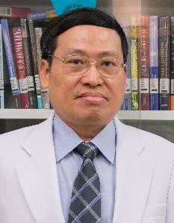
Asia/Oceania Regional Chair: Prasert Assantachai, MD Dr. Prasert Assantachai is an Associate Professor in the Department of Preventive and Social Medicine as well as Faculty of Medicine, Siriraj Hospital, of Mahidol University in Salaya, Thailand. His research interests include disease prevention and health promotion of older adults, cognitive impairments and dementia as well as caregiver burden and needs. As Associate Professor, Dr. Assantachai has received recognition for both his research and academic expertise. In 2000, he received
appreciation as an Outstanding intellectual of the 21st Century from the International Biographical Center in Cambridge, England; was awarded the Outstanding Clinical Research Award, in 2007; was acknowledged for skilled academic writing, in 2009, by Siriraj Hospital of Mahidol University; and, in 2013, Dr. Assantachai was granted the Siriraj Glory Award Faculty of Medicine, again from Siriraj Hospital. In addition to these achievements, Dr. Assantachai is currently President of the Association of Geriatric Medicine and Geriatric Medicine and recently elected the Asia/Oceania Regional Chair for the International Association for Gerontology & Geriatrics.

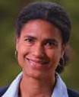
Africa Regional Chair: Isabella Aboderin, PhD Professor Isabella Aboderin holds a PhD from the School for Policy Studies, University of Bristol, UK (2000); an MSc degree in health promotion sciences from the London School of Hygiene and Tropical Medicine, UK, and a BSc degree in cellular and molecular pathology from the University of Bristol, UK. Professor Aboderin is a senior research fellow at the Oxford Institute of Ageing, University of Oxford (oia). Isabella leads the institute's program of work on Africa and is coordinator of the African Research on Ageing
Network (AFRAN). She has extensive expertise in qualitative research and experience of quantitative analysis and survey design. Her research interests center on three areas: social and life course determinants of health in old age, ageing and development in Sub-Saharan Africa (SSA), and intergenerational family support and social change in SSA.
North America Regional Chair: Kenneth Madden, MD Dr. Ken Madden is an associate professor of geriatric medicine at the University of British Columbia and the editor-in-chief of the Canadian Geriatrics Journal. His lab has examined the effect of exercise interventions in older adults with Type 2 diabetes, the ability of different forms of exercise to impact arterial stiffness in subjects at high cardiometabolic risk, and the impact of sedentary behaviors on cardiometabolic risk factors. He has also examined the impact of age and diabetes on postprandial cardiovascular
responses and orthostatic intolerance. He is division head of Geriatric Medicine at Vancouver General Hospital, and holds peer-reviewed grants from the Canadian Institutes of Health Research, the Heart and Stroke Foundation of Canada, and the Canadian Diabetes Association.
South America and Caribbean Regional Chair: Marianela Flores De Hekman, PhD Professor Marianela Flores De Hekman graduated from the Medicine Federal University of Santa Maria, Rio Grande do Sul, Brazil, and completed a medical residency at the Hospital São Lucas in Geriatrics and Gerontology of Pontifical Catholic University of Rio Grande do Sul, Brazil. She participated in training and research in the area of Geriatric Cardiology at TOKAI University School of Medicine, Japan, and worked at the Department of Geriatrics and Gerontology Hospital Moinhos de Vento,
based in Porto Alegre and Rio Grande do Sul in Brazil. She has held various positions to promote Geriatrics and Gerontology in the Latin America Region. She is the coordinator of the South Region of Brazil's Confederation of Associations and Societies Brazilian Osteoporosis and Osteometabolismo (CEBOM) and is a Permanent member of Consultative Board of the Brazilian Society of Geriatrics and Gerontology. She was President of the Brazilian Society of Geriatrics and Gerontology (2006-2008), President of the Commission of Ethics and Regulations of the Brazilian Society of Geriatrics and Gerontology (2008-2014), and a Director of the Latin American Education Committee area of Geriatrics and Gerontology (2007-2011).

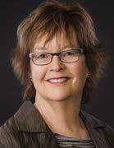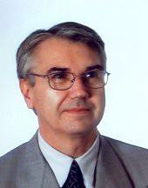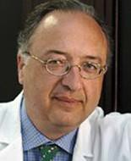

Norah Keating, PhD
GSIA, Program Chair
Jean-Pierre Michel, MD
WAA, Program Chair
Leocadio Mañas, MD, PhD
GARN, Program Chair

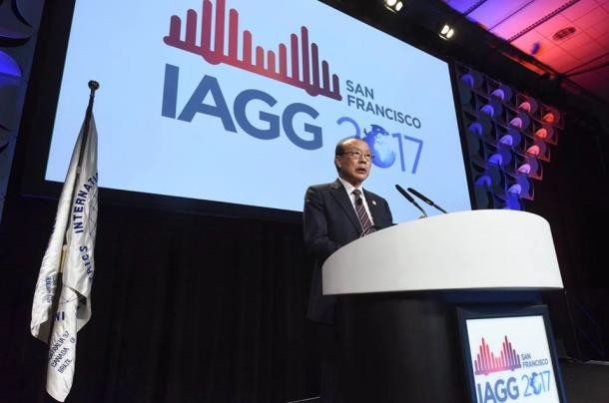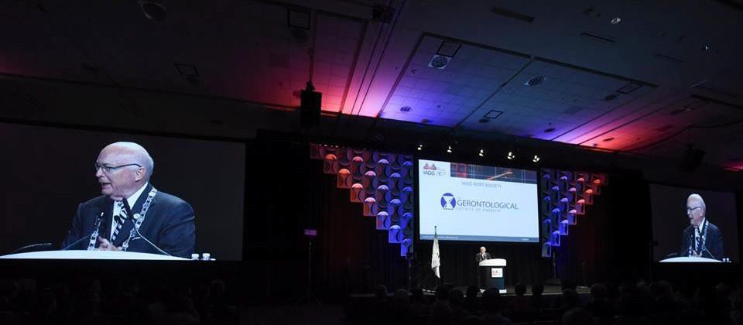21st IAGG WORLD CONGRESS: July 23~27, 2017, SAN FRANCISCO, CA (HIGHLIGHTS)

OVERVIEW

On the heels of a successful congress organized by the Gerontological Society of America (GSA), it is important to highlight many of the new innovative features including:

NEW FEATURES:
- AGE STAGE: As a collaboration between GSA and the IAGG Humanities and Arts Workgroup, Age Stage provided a venue to highlight the many ways creativity plays a role in aging.

- TECH DAY: Bringing together leading companies Tech Day engaged gerontologists, and entrepreneurs in developing technology solutions for older adults.

- IAGG TV: We are pleased to share with you the Opening Ceremony and Lecture video, special video content from IAGG TV

SOCIAL MEDIA:
  - TWITTER: During the week of the World Congress, nearly 12,000 tweets were shared using the meeting hashtag #IAGG2017. These tweets reached more than 31 million users around the world!

  - FACEBOOK: On Facebook, IAGG reached more than 250,000 users during the meeting. Be sure to visit facebook.com/iagg2017 to view all of the conference photos and tag yourself in the
albums!

PRESS:
- The World Congress issues press passes to more than 70 reporters in San Francisco including representatives from The Washington Post, The San Francisco Chronicle, Smithsonian,CNBC, New America, Media, Next Avenue, La Opinion, Sarasota Herald-Tribune, Kaiser Health News, The Louisiana Weekly, and several NPR affiliates, among others.

RESOURCES:
- IAGG 2017 Presentation Slides- http://www.onlineevent.com/iagg
- IAGG 2017 Program Book- https://www.iagg2017.org/images/documents/IAGG2017_Program_Final.pdf
- IAGG 2017 Abstract Book- https://academic.oup.com/innovateage/issue/1/suppl_1

21st IAGG WORLD CONGRESS PRESIDENTIAL AWARD RECIPIENTS
- The late Professor Nana Arba Apt from the African Region
- The late Professor Sutthichai Jitapunkul from the Asia/Oceania Region
- Professor Sang Chul Park from the Asia/Oceania Region
- Professor Yasuyoshi Ouchi from the Asia/Oceania Region
- Professor Dorothy Joan Hardy Deeg from the European Region
- Professor Jose Fernando Gomez Montes from the Latin American Region
- Professor Norah Keating from the North American Region

21st IAGG 2017 WORLD CONGRESS ATTENDEE SURVEY RESULTS:

CONFERENCE DEMOGRAPHICS:
- Total registered attendees: 6,052
- Total registered junior scholars: 1,317
- Total US based attendees: 3,299 (55%)
- Total international based attendees: 2,753 (45%)
- Top 10 countries represented: United States, Canada (389), Japan (300), Australia (211), United Kingdom (192), China (172), Korea (152), Brazil (146), Germany (124), Sweden (95)

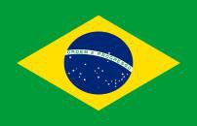

SURVEY RESPONSES:

An online survey was distributed to 5,902 IAGG 2017 World Congress participants in an effort to better engage attendee satisfaction with Congress programming and content. The survey was completed by 1,389 attendees. Here are the results:

- The attendees reported being the most pleased with the quality of the speakers, session topics, scientific content and applicability of this information to their work to their work.

- The top three primary objectives for attending the conference were: Presenting at the Congress; Professional and Personal Development; and Networking Opportunities.
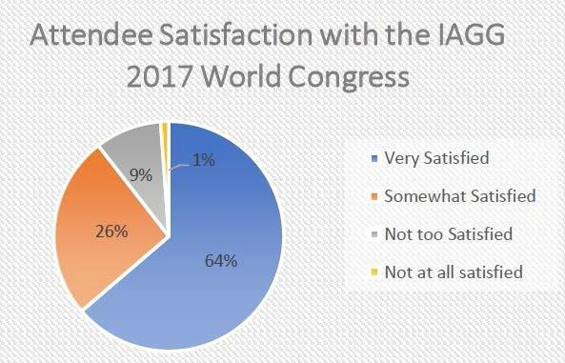
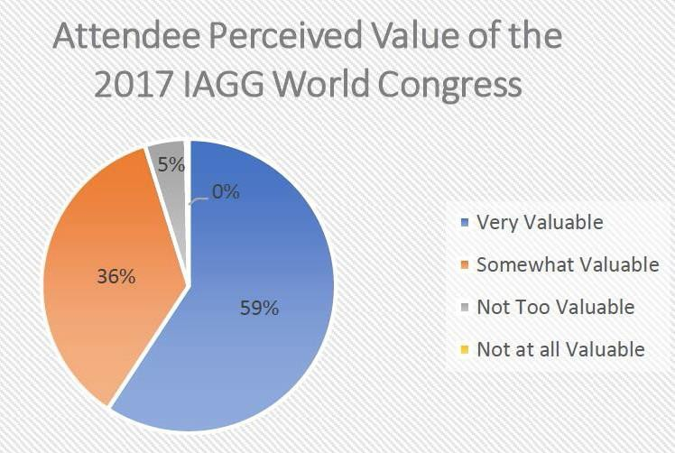

SATISFACTION: 96% of all attendees found attending the IAGG 2017 World Congress very valuable or somewhat valuable.
VALUE: 90% of all attendees were very satisfied or somewhat satisfied with the IAGG 2017 World Congress.

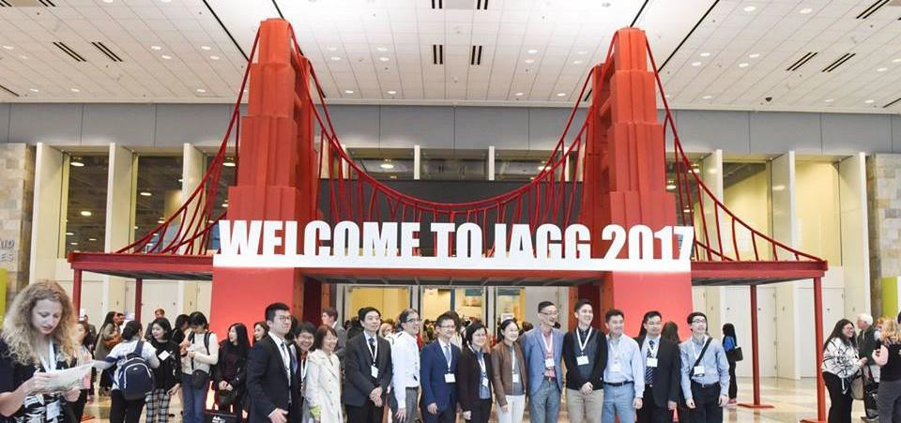

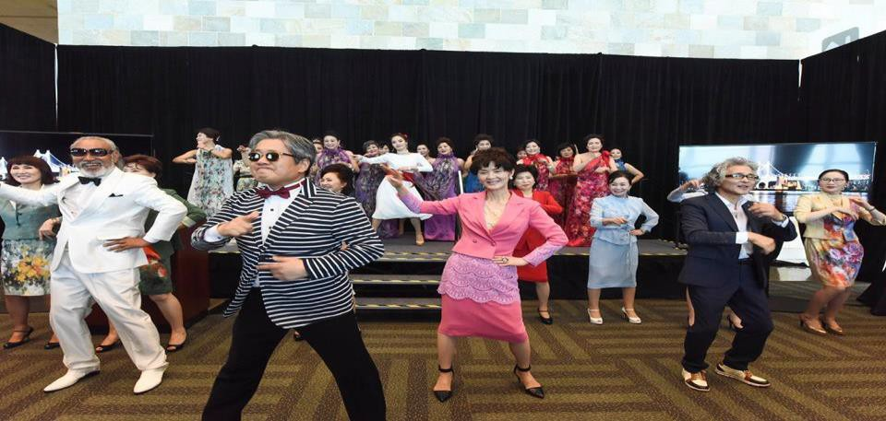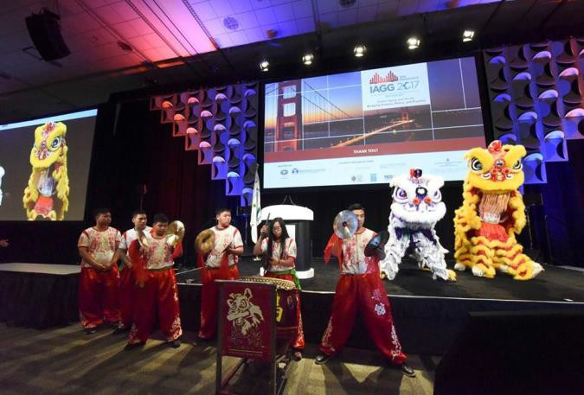

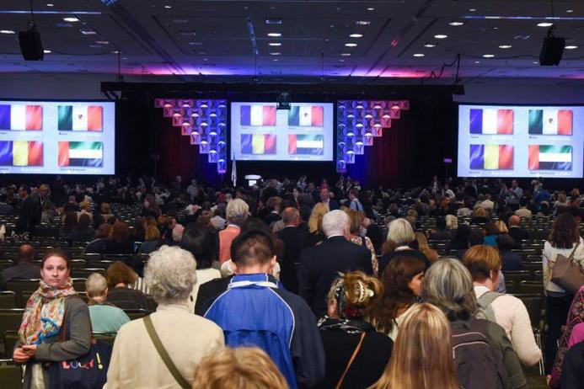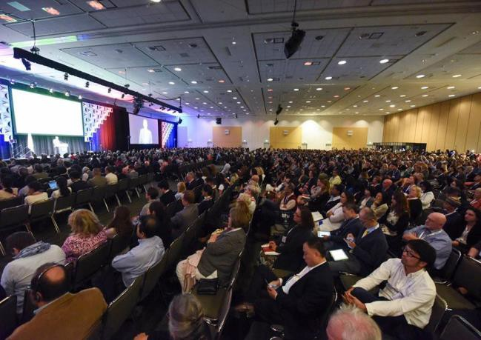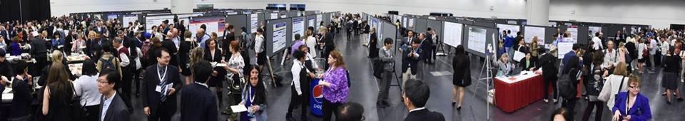

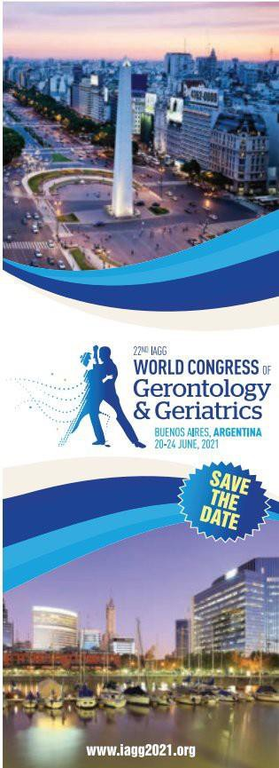IAGG 22nd WORLD CONGRESS

SAVE THE DATE:

22nd IAGG World Congress of Gerontology and Geriatrics

Buenos Aires Sheraton Hotel and Convention Center Buenos Aires, Argentina

June 20-24, 2021

www.iagg2021.com

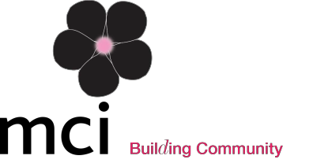

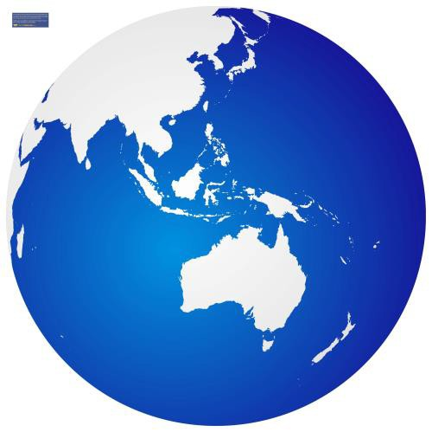
REGIONALHIGHLIGHTS
- During the 21st IAGG World Congress Regional Council meeting, outgoing Regional Chair, Professor Keith Hill, (Australia) handed over his title to incoming Regional Chair Professor Prasert Assantachai (Thailand). The Council thanked Professor Keith Hill for his role as Regional Chair for the past four years.

- Two regional scientific sub-committee chair positions were filled:
  - Biological Sciences Sub-Committee- Professor
    - Eun Seong Hwang, Department of Life Science, University of Seoul, Seoul, Republic of Korea,
  - Social Research and Planning Sub-Committee- Professor Julie Byles, Co-Director of the Hunter Medical Research Institute Public Health Research Program, University of Newcastle, Newcastle, NSW,Australia.
- The Philippine Society of Geriatrics and Gerontology was approved by a unanimous IAGG Council vote and admitted as a new member of IAGG during the 21st IAGG World Congress. Congratulations!

REGIONAL OBJECTIVES
- The regional executive council and local organizing committee continue to plan and prepare for the 2019 Asia/Oceania Regional Congress, which will be held in Taipei, Taiwan.

REGIONAL EVENTS
- May 27-29, 2017: 9th Asian Master Class on Ageing, Faculty of Medicine Siriraj hospital, Bangkok, Thailand
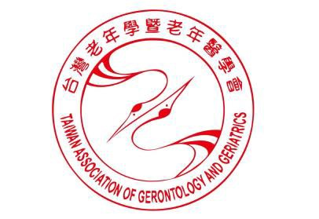
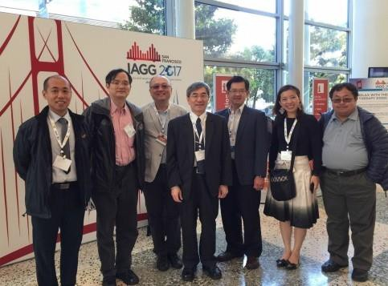
- October 24 -27, 2019: IAGG Asia-Oceania Regional Congress, Health & Wellbeing in the Silver World: From Bench to Policy, Taipei International Convention Center, Taipei, Taiwan. View program details HERE.

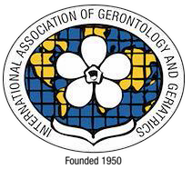
PLANNINGMEMBERS: Members of the planning association for the 11th IAGG Asia/ Oceania Regional Congress in attendance at the 21st IAGG World Congress.

SOUTH AMERICA AND CARIBBEAN (COMLAT) REGION

REGIONAL HIGHLIGHTS
  - José R Jauregui was selected as IAGG President Elect and Miguel Acanfora, Vice President- Secretary Elect the term will begin in 2021.
  - Dr. Fernando Botta will be the next COMLAT President beginning his term in April of 2019.
  - The Argentine 14th congress of Gerontology and Geriatrics. The congress happened in early September in Mar del Plata, Argentina. The event was a huge success with 2047 participants and 158 presented papers.

REGIONAL OBJECTIVES
  - As we prepare for the 2021 IAGG World Congress, we will work to solidify the Argentinean team integrated by both cohosting societies, working together for the organization and implementation of its sub-committees.

REGIONAL EVENTS
  - November 16, 2017: Workshop on Geronto-psychiatry in Buenos Aires, Argentina.
  - The Regional executive council and local organizing committee continue to plan and prepare for the 2019 Latin American & Caribbean Regional Congress, which will be held in Uruguay.
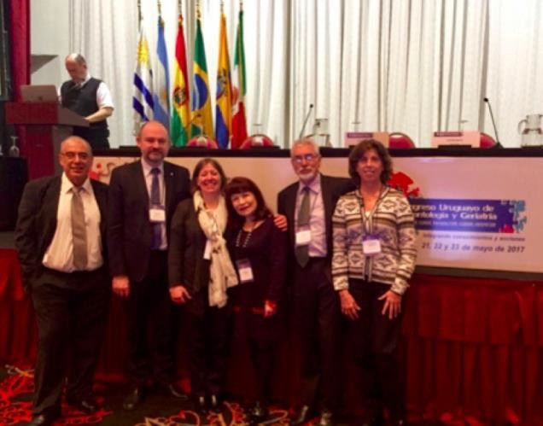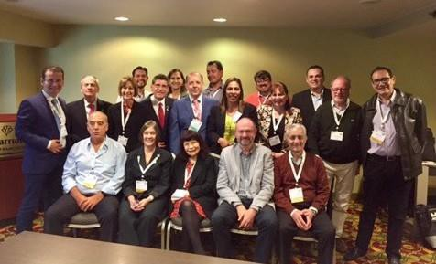
COMLAT ACTIVITIES: Members who participated in the COMLAT meeting in San Francisco (LEFT). First COMLAT course of Gerontology of 2017 in Montevideo City (RIGHT).

EUROPEAN REGION

REGIONAL HIGHLIGHTS
  - The European Region is honored to host the IAGG World Congress 2025 in Amsterdam, the Netherlands.
  - IAGG-ER was approached to send an ExCom representative to participate at the 4th Ministerial Conference on Ageing, September 21-22, 2017 in Lisbon, Portugal. The meeting was focused on strategies for individuals and societies to enhance and harness the potentials of living longer. Professor Boo Johansson, Department of Psychology of the University of Gothenburg, participated as the IAGG-ER representative at the meeting.
  - An agreement was made with Springer Publishers of the journal Biogerontology, to affiliate with the IAGG-ER and to show the IAGG logo on the front cover of the journal. This agreement came in to effect from vol.3, issue 3, 2017, and in the first instance will remain effective for the next 3 years.
  - The Azerbaijan Society of Gerontologists was approved by a unanimous IAGG Council vote and admitted as a new member of IAGG during the 21st IAGG World Congress. Congratulations!

REGIONAL OBJECTIVES
  - Promoting and Assisting in Arrangements for the 2019 European Congress: In 2019, individual scientists will be able to submit papers, posters, and symposia to the congress. In addition, there will be invited lectures and presidential symposia devoted to excellent research to secure a multidisciplinary format of the congress.
  - Strengthening European Ageing Research: Achieving this objective includes strengthening collaboration with European journals on ageing research, European scientists and influencing European funding for ageing research, and underscoring the importance of gerontology and geriatrics for meeting the prospective demographic challenges.
  - Promoting Scientists in Ageing Research: IAGG-ER recognizes that support for early career scientists, who have made important contributions to interdisciplinary ageing research, should be enhanced. An option is establishing an award for young and successful scientists. IAGG-ER is currently outline necessary preparations for this award.

REGIONAL EVENTS
  - November 22-24, 2017: IAGG-ER Socio-Behavioral Section Workshop, Loneliness in the Older Adults, Menéndez Pelayo International University of Valencia. View program details HERE.
  - May 16 – 18, 2018: 4th European Stroke Organization Conference ESOC 2018, Gotheburg, Sweden.
Abstract Submission Deadline: 22 January 2018
  - May 23-25, 2019: IAGG European Region Congress 2019, Towards Capability in Ageing – from cell to society, Gothenburg, Sweden at the Swedish Exhibition and Congress Centre. View program details HERE.
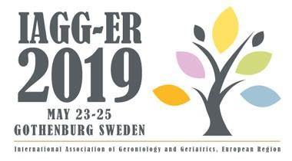

NORTH AMERICAN REGION

REGIONAL HIGHLIGHTS
  - In a recent post on the British Geriatrics Society Blog, Canadian Geriatrics Society President Frank Molnar explores the 5Ms framework developed with Mary Tinetti, MD, for describing geriatrics expertise.
  - The geriatric 5Ms can make the complexities of geriatrics more accessible to older adults, caregivers, and colleagues.

The Geriatric 5M’s Framework as discussed in the Regional Highlights (ABOVE).

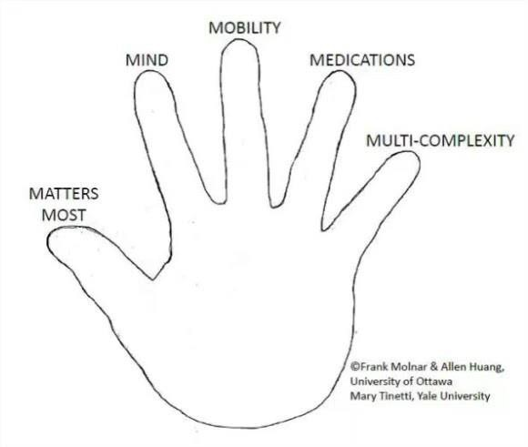
REGIONAL OBJECTIVES
  - Increase outreach to member organizations: The current organizations participating in NARC consist of the Gerontological Society of America, the Canadian Geriatrics Society, and the Canadian Association of Gerontology. One of the main goals is to increase the visibility of IAGG at these organizations, by continuing participation in regional meetings and joint symposiums.
  - Encouraging knowledge exchange (both research and educational) between regions and within NARC itself.

REGIONAL EVENTS
  - April 19-21, 2018: The 38th Annual Scientific Meeting (ASM) of the Canadian Geriatrics Society, Advances in Care: From Patient to Technology, Hotel Bonaventure, Montreal, Quebec, Canada. View program details HERE.
  - October 17-20, 2018: 11th World Stroke Congress (WSC 2018) in Montreal, Canada.
  - November 14-18, 2018: Gerontological Society of America’s 2018 Annual Scientific Meeting, The Purposes of Longer Lives, John B. Hynes Veterans Memorial Convention Center, Boston, Massachusetts. View program details HERE.

AFRICAN REGION

REGIONAL HIGHLIGHTS
- Building on foundations laid by the first and second IAGG Africa region conferences held in October 2012 in Cape Town and December 2016 in Nairobi, a third regional congress will be convened in 2020. The venue and dates are yet to be confirmed.

REGIONAL OBJECTIVES
- Internal consolidation: Following the formal adoption of its by-laws, the stage is now set for a consolidation of the IAGG Africa region’s structures and operation. A first step in this regard will be the convening of an inaugural council meeting and election of a new
Regional Chair and other secretariat officers. Decisions will be made on modes of communication between members and secretariat, and on region-wide strategic activities to be pursued until 2021.
- Promotion of a focused, region-wide research endeavor: The IAGG Africa region – through partnerships – will seek to support an advancement of high-quality scientific research and debate in gerontology and geriatrics in sub-Saharan Africa. The aims are to foster science that:
- Engages explicitly and critically with salient, typically western-derived constructs to generate incisive, ‘home-grown’ theorizing, that both captures local realities and enriches understandings of global ageing.
- Helps move policy to action by clarifying the ‘case’ for investments in the well-being and rights of older persons as part of broader national development agendas, and by identifying relevant and sound practice models.
- Building capacity: The IAGG Africa region – again through partnerships –will seek to support more extended training initiatives for both emerging and established scholars in gerontology and geriatrics as well as for
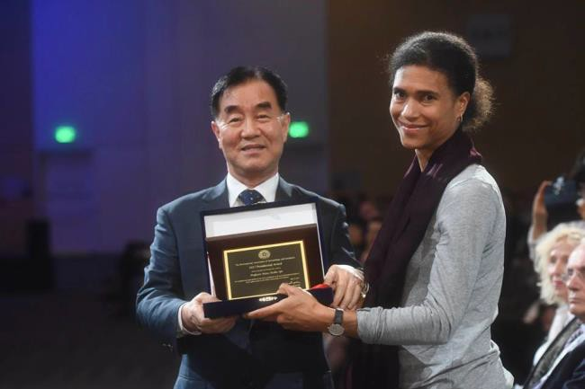
practitioners or professionals in health and other sectors.
  - Developing the next generation: The IAGG Africa region seeks to lend support to the establishment of 1 - 2 undergraduate and postgraduate programs of excellence in undergraduate and postgraduate gerontology and geriatrics.
  - Growing the number of national societies: A final aim for the IAGG Africa region is to promote the establishment of more national societies of gerontology and/or geriatrics, and to support their applications for IAGG membership.
PRESEDENTIAL AWARD: Dr. Isabella Aboderin (LEFT) is seen receiving the award on behalf of Professor N a n a A r b a Apt at t h e I A G G 21st World Congress.

- New Director: Leocadio Rodríguez Mañas, MD, PhD was elected as the new Director of GARN following predecessor Bruno Vellas MD, PhD.
- At the end of last year (December, 2016), IAGG-GARN was composed by 584 centers, the majority of them based in Europe (297) but with a strong participation of groups established in Asia/Oceania region (140) and in North America (88).

PROGRAM OBJECTIVES
With this outstanding background in mind, the next period should be dedicated to three main tasks:
- A refinement in its organizational profile: Make the organization and management of the Network more participative by providing a cross-continental perspective
- The relationship with the managerial structure of the IAGG, including the Scientific Committee: The growth of the Network makes it advisable to develop a bi-annual Plan, with updates of the same if necessary.
- To raise joint research efforts in order to take advantage of the high potential stemming from GARN's 548 research centers, thus promoting transnational and transcontinental research programs, which remains to be one of the networks main objectives.

GSIA: GLOBAL SOCIAL INITIATIVE ON AGEING

PROGRAM HIGHLIGHTS
- The GSIA held a strategic planning meeting at the World Congress of Gerontology and Geriatrics in July. Its purpose was to create an action agenda for the upcoming 4 years.
- In September and October, the following GSIA activities were undertaken toward creating a 4-year plan:
- Discussions are underway concerning GSIA collaboration with European scholars to present a master class and symposia at the European Regional Congress in May 2019 in Gothenburg, Sweden.
- Anita Liberalesso Neri (Brazil) and Jaco Hoffman (South Africa) attended the COST Action Network meeting on ageism, in Bucharest, Romania.
- Purpose of the invitation was to build global connections between scholars in Europe and other regions around issues of ageism and its policy impact.
- Norah Keating (GSIA director) attended a COST Action Network meeting on social exclusion in Brno, Czech Republic.
- An outcome of the meeting will be to develop frameworks for policy impact across the 39 European countries represented in the network.
- Peng Du (China) and Norah Keating (GSIA director) are advisors to the World Health Organization (Kobe Centre) will attend a meeting in Kobe, Japan to discuss findings from projects in diverse regions. Findings will inform the GSIA agenda around the importance of social and policy contexts of ageing.

PROGRAM OBJECTIVES
- Position IAGG as a responsive, insightful and visible voice of global issues on ageing
- Create global evidence of how key contexts of ageing (people, place and policy) influence well-being of older people.
- Solidify the master class program, underpinned by the principle of inclusion of scholars from all Regions.
- Create outlets for timely, ongoing, widespread and active knowledge mobilization with key regional and international organizations and governments

WAA: WORLD ACADEMY ON AGEING (IAGG-World):

PROGRAM HIGHLIGHTS
- Jean-Pierre Michel, MD, was appointed the program director of the IAGG’s World Academy on Ageing (IAGG-World), a program which seeks enhancing the academic foundation in the field of geriatrics and gerontology.

PROGRAM OBJECTIVES
- In complete partnership with the World Health Organization and the United Nations, IAGG- World drafted “Quality Standards” in an effort to streamline future Master Classes on Aging.
- IAGG-World aims to enrich existing programs and to extend program activities to new global regions, which, in the past, did not benefit from this high level educative initiative in gerontology and geriatrics. These global regions include, but are not limited to, Southeast Asia, North Africa and Sub Saharan Africa.

PROGRAM EVENTS
- May 28-30, 2018: 1st IAGG East South Master Class on Aging (combined with the 9th IAGG Asian Oceania Master Class on Aging), Dementia Care, Bangkok, Thailand.
  - This teaching activity will be under the co-presidency of Professors Prasert Assantachai(Bangkok), Hidenori Arai (Nagoya) and Liang Kung Chen (Taipei). All information could be provided by asking Professor Prasert Assantachai (Bangkok), prasert.uts@mahidol.ac.th

Council of Student Organizations

PROGRAM HIGHLIGHTS

During the 21st IAGG World Congress, the Council of Student Organizations (CSO) held Committee elections, establishing new leadership for 2017-2021. Questions or ideas? Let us hear from you at iaggcso@gmail.com

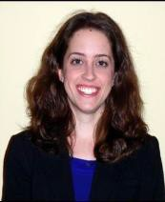
President: Jaime Hughes, PhD Dr. Hughes is a Postdoctoral Fellow at the Center for Health Services Research with the Department of Veterans Affairs in Durham, NC. She received her PhD from the University of North Carolina at Chapel Hill and her MPH and MSW degrees from the University of Michigan at Ann Arbor. As a health services researcher, she focuses on developing and disseminating multicomponent sleep and physical activity interventions for frail older adults. She also served in multiple leadership roles with the Gerontological Society of America’s Emerging
Scholar and Professional Organization.

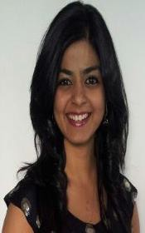
Vice President: Saima Rajabali Saima is a PhD candidate in the Department of Medicine at the University of Alberta, Edmonton, Canada. She previously studied medicine and medical sciences at Baqai Medical University, Pakistan, and the University of Alberta. Her research interests include healthy aging, chronic disease self-management, geriatric clinical trials and involvement of older adults as research partners.

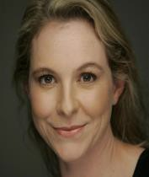
Secretary/Treasurer: Justine Irving Justine is a PhD candidate, currently teaches undergraduate and postgraduate students in gerontology for Flinders University in South Australia while also undertaking a doctorate in gerontology. Justine has a Master of Gerontology, Bachelor of Psychology and an Advanced Diploma in Journalism and has a diverse working history comprising research and management consulting roles.

Current UN Representatives and Appointments

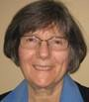
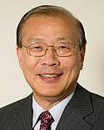
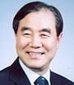
REPRESENTATIVES AT THE UN HEADQUARTERS (NEW YORK)
Toni Antonucci Martha Bial Heung Bong Cha Sung Jae Choi

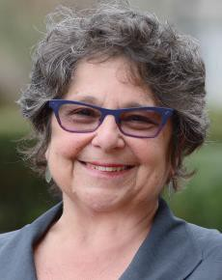
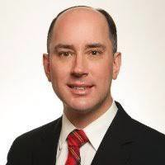
Ruth Finklestein Laura Mello Machado John W. Rowe Hans Stohrer

REPRESENTATIVES AT THE UN EUROPEAN MISSIONS (GENEVA)
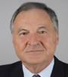
Alain Franco

HIGHLIGHTS
- Four-Year Report of IAGG Representation and Activities at the UN (2013-2017): This Report was the result of a combined effort from IAGG Representatives to the UN Laura Machado, Martha Bial, and Hans Stohrer, with the review of IAGG Immediate Past Secretary-General/Vice-President Sung Jae CHOI. This Report was orally delivered by IAGG Representatives to the UN Laura Machado, Martha Bial, and Hans Stohrer to the governance meeting of the IAGG Council at the 21st IAGG World Congress in San Francisco on July 24, 2017. The Report contained the following five sections. Overview: Role of IAGG at the United Nations, Activities 2013-2017, Oral and Written Statements 2013-2017, Advocacy with other NGOs on Ageing at the UN, and Challenges and Recommendations.
- UN Representative Alain Franco attended the 2017 UNECE Ministerial Conference on Ageing in Lisbon, Portugal, concerning the future of human rights enjoyed by older people. The research declaration presented during the conference established a baseline for the future of IAGG and national societies' activities in Gerontological and Geriatrics and gives strong avenues for future innovation.
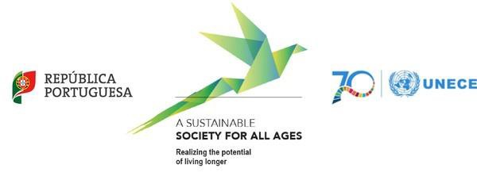

OBJECTIVES

- IAGG Mission and Mandate at the UN: To enhance its visibility and to fulfill its mission on the world stage, IAGG needs a clear mission and mandate for its work at the UN, aligned to the IAGG mission set out in its By-laws (the mission of IAGG is to promote the highest level of achievement in gerontological research and training world-wide); and IAGG should chart long-term goals at the UN and plan strategies to achieve those goals.
- Strengthen IAGG- UN Relationship with other NGOs on Ageing: Effective IAGG action, and cooperation with other NGOs on the world stage at the UN, often requires flexibility and authority from IAGG Secretariat to its Representatives to move quickly.
- Solicit Input of IAGG Voices of Older Persons at the UN: To strengthen the visibility of ageing populations in societies across the world, the functional bodies of the United Nations continually seek the input and voices of older persons. IAGG, through the considerable reach of its Member Societies and professionals across the world, has an important role to play to represent the voices of older persons internationally.
- Include Input of IAGG Member Societies at the UN: The IAGG mission, agenda, and policy interventions at the UN should reflect the valuable perspectives of its IAGG Member Societies and professionals across the world.
- Promote Input of IAGG Gerontological and Geriatric Research at the UN: The IAGG Council should consider developing an IAGG policy arm to monitor, cull, and abstract research papers, news articles, and websites, to report research findings bearing on issues before the UN, and to transmit these directly to the UN Focal Point on Ageing or to the IAGG Representatives to the UN for transmission.

UPCOMING EVENTS

SOUTH AMERICA AND CARIBBEAN (COMLAT) REGION

November 2017
- November 16: AGA workshop on Geronto-Psychiatry Buenos Aires, Argentina
- XXXII International Congress of MAGG Mexico City, Mexico

June 2021
- June 20 – 24: 22nd IAGG World Congress, Buenos Aires Sheraton Hotel and Convention Center

EUROPEAN REGION

November 2017
  - November 22-24, 2017: IAGG-ER Socio-Behavioral Section Workshop, Loneliness in the Older Adults, Menéndez Pelayo International University of Valencia. View program details HERE.

May 2018
  - May 16 – 18, 2018: 4th European Stroke Organization Conference ESOC 2018, Gotheburg, Sweden.
Abstract Submission Deadline: 22 January 2018

May 2019
- May 23 – 25, 2019: 9th European Congress of Gerontology and Geriatrics, Gothenburg, Sweden

NORTH AMERICAN REGION

April 2018
- April 10-13: The Annual conference for Nurses Improving Care for Health System Elders (NICHE), Atlanta, Georgia, USA.
- April 19 – 21: The 38th Annual Scientific Meeting (ASM) of the Canadian Geriatrics, Society Montreal, Quebec, Canada

October 2018
  - October 17-20: 11th World Stroke Congress (WSC 2018) in Montreal, Canada.

November 2018
- November 14-18: GSA’s 2018 Annual Scientific Meeting at the John B. Hynes Veterans Memorial Convention Center in Boston, MA. Abstract submissions open December 15th, 2017.

ASIA & OCEANIA REGION

May 2017
- May 27 - 29: 9th Asian Master Class on Ageing, Faculty of Medicine Siriraj hospital, Bangkok, Thailand

IAGG ADMINISTRATION

NEW ADDRESS FOR IAGG HEADQUARTERS

IAGG Headquarters:
722 West 168th Street, New York, NY 10032
Telephone: +1212-305-0294
Fax: +1 212-305-3405
Website: http://www.iagg.info
E-mail: MSPH-IAGG@cumc.columbia.edu

Information for Wire Transfer of Membership Dues to IAGG US Dollar Bank Account:
(PLEASE NOTE: We still finalizing bank account details. We will send out a separate email regarding details and updates.)

Bank Name: Bank Address: Bank Account #: Swift code: Beneficiary: IAGG
E-mail: MSPH-IAGG@cumc.columbia.edu

Reminder for All IAGG National Society Members
Please send us your updated information related to your membership (number of members, name of council member(s), name of contact, e-mail & postal addresses, phone/fax numbers.

CONNECT WITH US ON SOCIAL MEDIA:

